Lab 6: Code and Branch Coverage Analysis

Name: Amoghaa R
SRN: PES2UG24CS625
Branch: Computer Science and Engineering
Course: Software Engineering

1. Objective
- Understand the difference between code coverage and branch coverage.
- Use coverage to measure, analyse, and improve test coverage.
- Interpret coverage reports and identify untested paths in code.
- Practise writing test cases that cover edge cases and decision branches.

2. Application Under Test
Application: Blood Donation Screening
Source file: blood_donation_screening.py
The objective of this exercise is to develop and execute test cases for the given blood donation screening application and measure its code coverage and branch coverage using the Python Coverage tool and Pytest.
3. Code Coverage Analysis
3.1 Test Case Implementation
The test cases were implemented in:
CodeCoverageTest_PES2UG24CS625_application.py
A total of 12 test cases were executed to test the application statements and improve code coverage.

3.2 Code Coverage Result
Achieved Code Coverage: 100%
All 45 executable statements in the application were covered, with 0 missed statements.
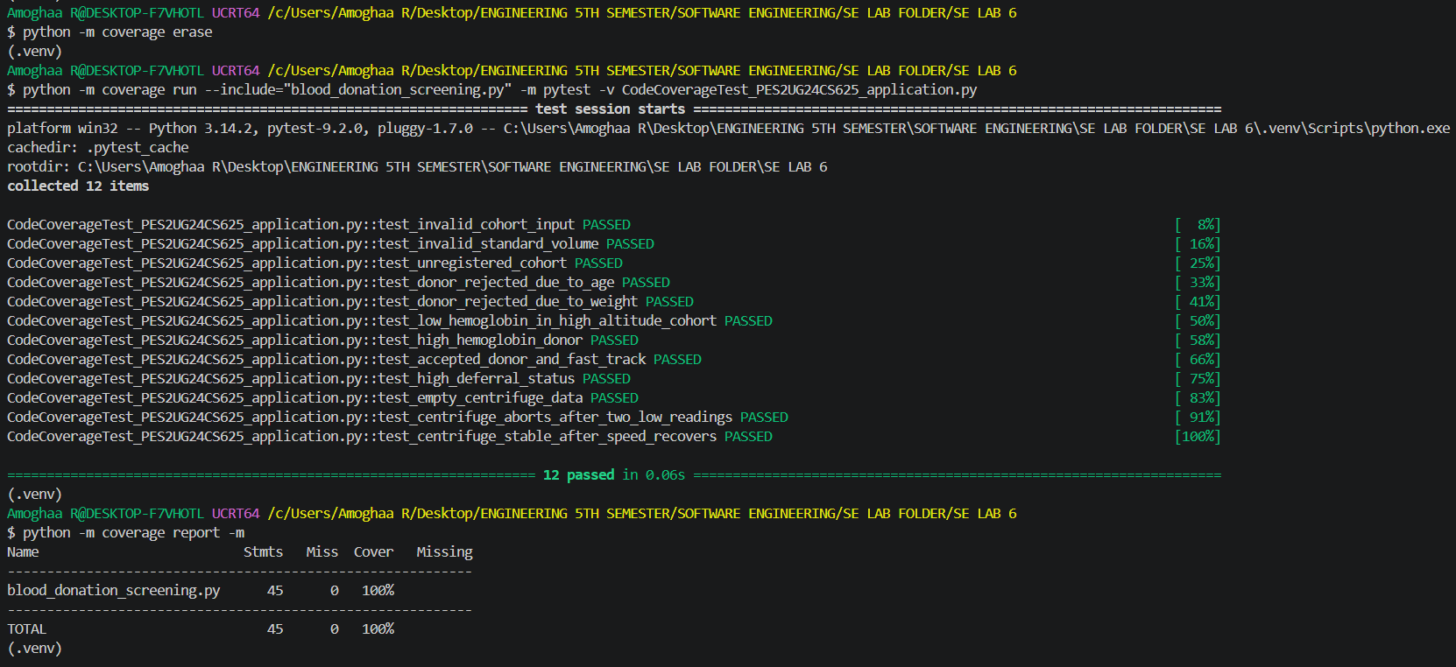

3.3 GitHub Commit – Code Coverage
The code coverage test cases and their corresponding terminal evidence were committed and pushed to the GitHub repository.
Commit message: Add code coverage test cases with 100 percent coverage
Figure 2: GitHub Commit – Code Coverage Test Cases (9f7fc95)
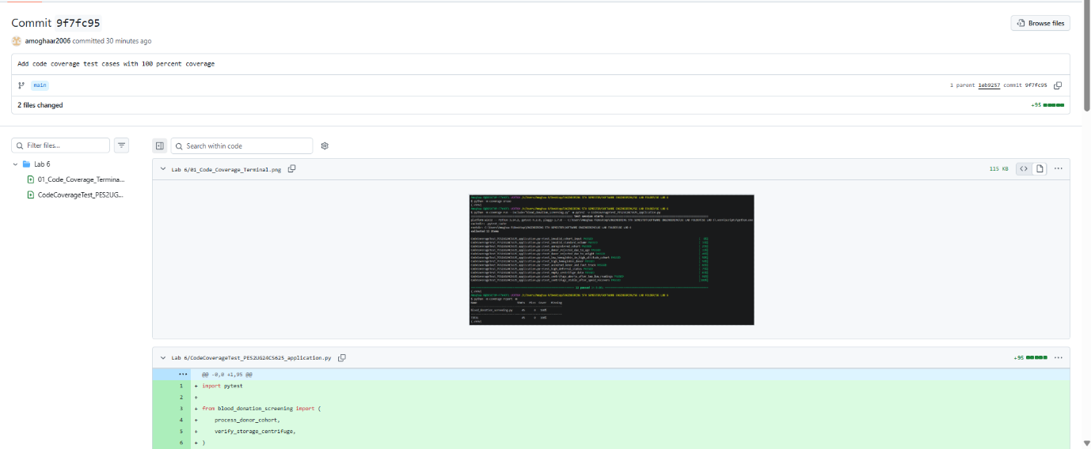

4. Branch Coverage Analysis
4.1 Test Case Implementation
The test cases were implemented in:
BranchCoverageTest_PES2UG24CS625_application.py
A total of 18 test cases were executed to cover the different decision outcomes and branches in the application.
4.2 Branch Coverage Result
Achieved Branch Coverage: 100%
All 45 executable statements and all 32 branches were covered, with 0 missed statements and 0 partial branches.

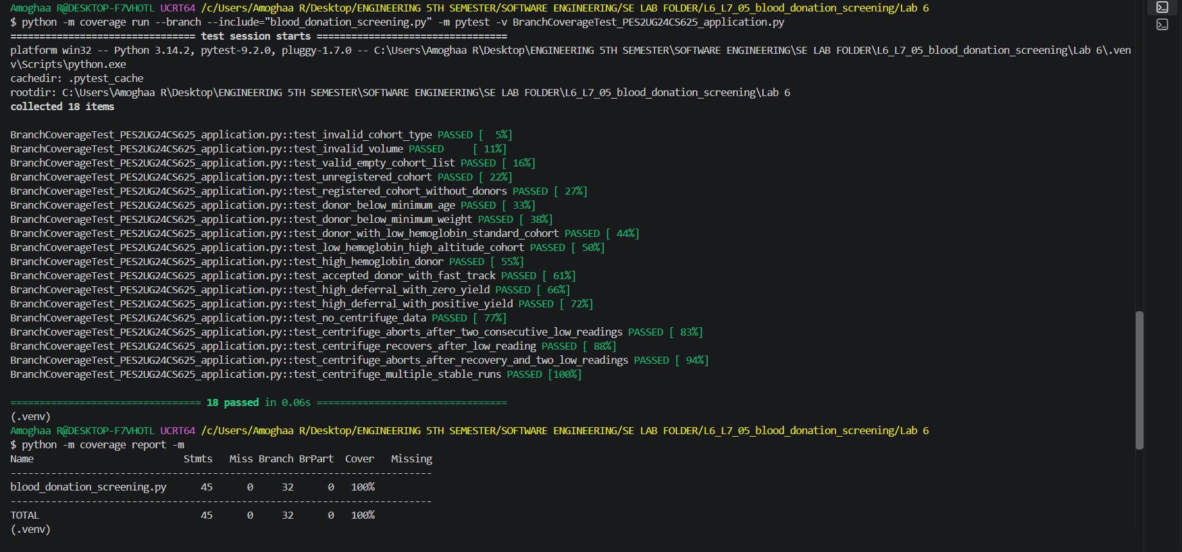

4.3 GitHub Commit – Branch Coverage
The branch coverage test cases and their corresponding terminal evidence were committed and pushed to the GitHub repository.
Commit message: Add branch coverage test cases with 100 percent coverage
Figure 4: GitHub Commit – Branch Coverage Test Cases (ce21f41)
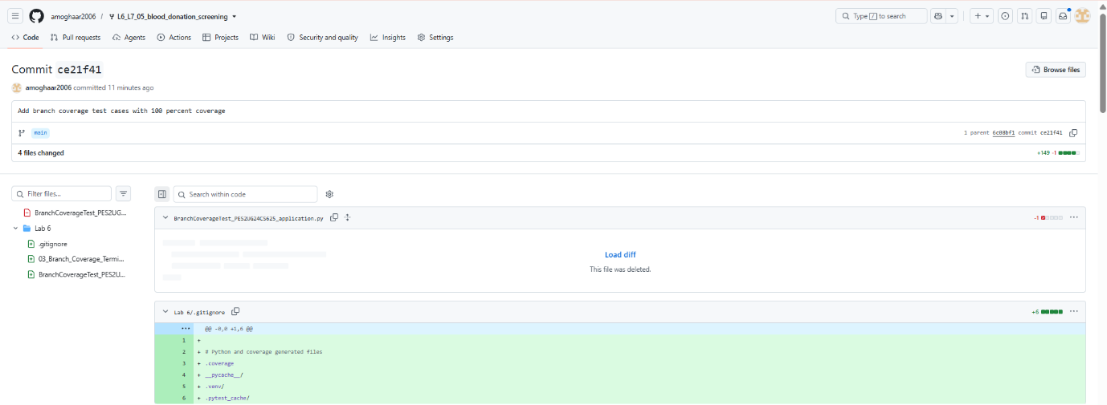

5. Conclusion
The code coverage and branch coverage analysis of the Blood Donation Screening application was successfully completed.
The test suite achieved 100% code coverage and 100% branch coverage, satisfying the minimum coverage requirement of 90%.
This exercise demonstrated how systematic test case design can identify untested statements and decision branches and improve software testing effectiveness.

6. GitHub Repository
Repository: L6_L7_05_blood_donation_screening
GitHub URL: https://github.com/amoghaar2006/L6_L7_05_blood_donation_screening
The test files and terminal evidence have been committed and pushed to the repository. The work was completed using two separate commits for code coverage and branch coverage.

